EXPT NO:2 | Implementation of data visualization techniques
DATE: 06.01.2026 | Implementation of data visualization techniques

PRE-LAB QUESTIONS (PROVIDE BRIEF ANSWERS TO THE FOLLOWING QUESTIONS)

1. Why is exploratory data analysis critical before model building?
EDA helps understand data patterns, detect outliers, and identify missing values before applying machine learning models.

2. How do distributions influence algorithm selection in ML?
Some algorithms assume normal distributions, while skewed data may require transformation or different models.

3. What insights can outliers provide in business data?
Outliers may indicate fraud, unusual customer behavior, or data entry errors.

4. Why are visual summaries preferred over raw tables?
Visuals reveal patterns and trends quickly, making interpretation easier.

5. How does visualization improve business intelligence?
It helps stakeholders make faster, data-driven decisions.
IN-LAB EXERCISE:
OBJECTIVE:

To explore data distribution and variability using advanced visualization techniques.
SCENARIO:
A startup analyzes e-commerce transaction data to understand customer spending behavior and detect abnormal purchase patterns.

IN-LAB TASKS (Using R Language)
- Plot histogram of transaction amounts
- Use boxplot to detect outliers
- Create heatmap of monthly sales intensity

CODE:

# Lab Exercise by Student: 23BAD109
library(ggplot2)
library(dplyr)
library(lubridate)
# Read the ecommerce dataset
ecommerce <- read.csv("2.ecommerce_transactions.csv")
head(ecommerce)
# Histogram of Transaction Amounts
ggplot(ecommerce, aes(x = Transaction_Amount)) +
geom_histogram(bins = 30, fill = "skyblue", color = "black") +
labs(
title = "Histogram of Transaction Amounts",
x = "Transaction Amount",
y = "Frequency"
) +
theme_minimal()
# Boxplot of Transaction Amounts
ggplot(ecommerce, aes(y = Transaction_Amount)) +
geom_boxplot(fill = "orange") +
labs(
title = "Boxplot of Transaction Amounts",
y = "Transaction Amount"
) +
theme_minimal()
# Convert Transaction_Date to Date format and extract Month
ecommerce$Transaction_Date <- as.Date(ecommerce$Transaction_Date)
ecommerce$Month <- month(ecommerce$Transaction_Date, label = TRUE)
# Summarize total sales by month
monthly_sales <- ecommerce %>%
group_by(Month) %>%
summarise(Total_Sales = sum(Transaction_Amount))
# Heatmap of Monthly Sales Intensity
ggplot(monthly_sales, aes(x = Month, y = 1, fill = Total_Sales)) +
geom_tile(color = "white") +
scale_fill_gradient(low = "lightyellow", high = "red") +
labs(
title = "Heatmap of Monthly Sales Intensity",
x = "Month",
y = "",
fill = "Total Sales"
) +
theme_minimal() +
theme(axis.text.y = element_blank(),
axis.ticks.y = element_blank())
# Roll number
my_roll_no <- "23BAD109"
print(paste("Lab completed by roll number:", my_roll_no))

OUTPUT :

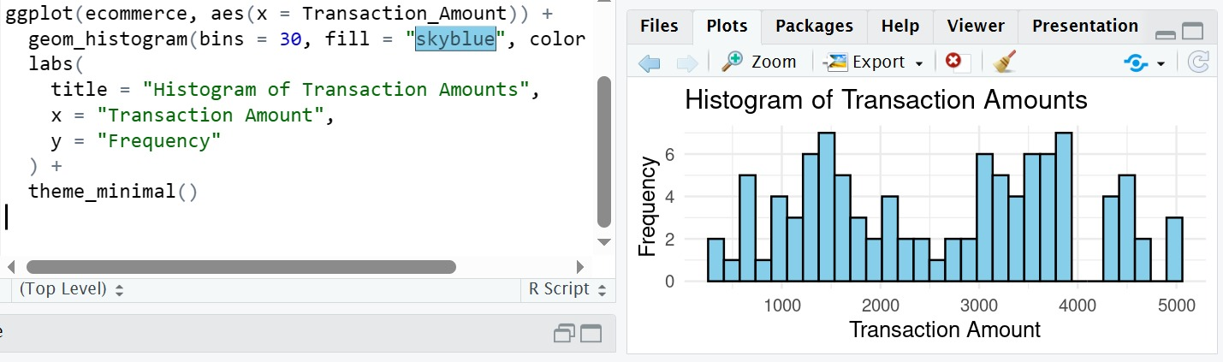

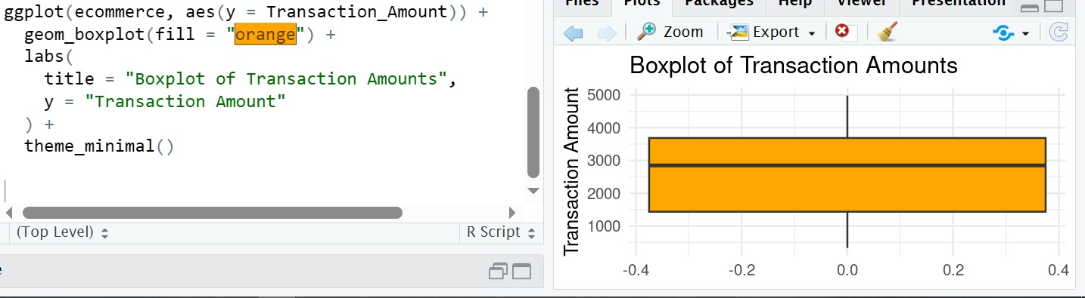

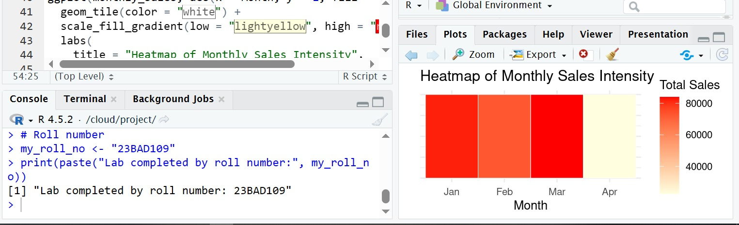

POST-LAB QUESTIONS (PROVIDE BRIEF ANSWERS TO THE FOLLOWING QUESTIONS)

1. What does right-skewed distribution indicate about customer behavior?
Most customers make small purchases, while a few make very large purchases.

2. How can detected outliers impact business decisions?
They can signal high-value customers or potential fraudulent transactions.

3. Which visualization best supports anomaly detection?
Boxplots are most effective for detecting anomalies.

4. How does EDA improve AI model accuracy?
By cleaning data, handling outliers, and selecting relevant features.

5. How can visualization guide feature engineering?
It highlights important variables and relationships for feature creation.

ASSESSMENT
Description | Max Marks | Marks Awarded
Pre Lab Exercise | 5
In Lab Exercise | 10
Post Lab Exercise | 5
Viva | 10
Total | 30
Faculty Signature

